- Objective / Purpose

This working instruction is intended to serve as guideline to assist the smooth handling of the initial sample process for components. Objective of the initial sampling process is to determine if all design records and specification documents have been completely understood by the supplier and if the production is able to manufacture parts which fulfill these requirements during the actual production (series production) with the pre-determined production quantity.
The supplier is responsible for the execution and correctness of the test and measurement results of the sample test. The purchaser reserves the right of cross-checking.

- Scope

- JULABO GmbH
- Supplier of JULABO GmbH

- Abbreviations

See Intranet Organization contacts/codes/abbreviations list of internal abbreviations

- Terms and definitions

First sample
First samples are products which were manufactured with standard equipment under standard conditions. Sampling with initial samples is called initial sample test and it serves as evidence for serial capability. Sampling for the release of production processes and products must be performed with initial samples. A positive or negative assessment of the initial sample (incl. documentation) by the purchaser results in the release of the product and the serial production or rejection of it.

Pre-serial sample
Pre-serial samples are manufactured with tools for small series or near-series systems which guarantee manufacturing process reliability. The applied manufacturing method corresponds with the subsequent serial production. To safe-guard the series start-up phase the products can be installed in pre-series products both with regard to their quality and produced numbers and are therefore suited for sampling.

Other samples
Other samples (DIN 55350, part 15) are products and material which are manufactured under not entirely serial conditions. Other samples may not be used for initial sample release. The release of other samples means that the product complies with the specifications, but it is not equivalent to serial release and does not give reason to waive the initial sample release procedure.

- Applicable Documents

- Conditions of purchase for production material, spare parts and direct manufacturing equipment for our products
- Quality and environmental standards demanded from suppliers
- Production creation process VA-RD-003
- Form: Initial Sample Test Report

- Amendments

This work instruction is reviewed regularly by the responsible person and amended as necessary.

- Instruction

All areas / departments / groups listed at item 2 are to be instructed on new and/or amended procedures.

- Description

Sequence
The supplier carries out all necessary tasks for the sampling on the basis of the established criteria, characteristics, and documentation.

The supplier checks the completeness and the fulfillment of the specifications, creates and signs the release forms. The supplier forwards the initial samples incl. the required documentation to the purchaser on schedule. If deviations regarding completeness and fulfillment of tasks occur in the course of the release procedure, the cause has to be determined and corresponding, corrective measures are to be initiated. The purchaser has to be informed.

The purchase evaluates the transmitted or presented documents and samples. The single and total release status is added to the cover page of the report. The release status is communicated to the supplier on the cover page.

Quantity of random samples:

Product | Quantity of random samples | Comments
Sheet metal structural component | 3 pieces
Injection molding parts | 5 pieces | For specific characteristics the process capability must be verified for at least 25 parts, if required from purchaser.
All others | 5 pieces

When are initial samples required?

Initial samples are requested as a separate position in the order:
- New parts and new components (also for sample parts and sample components)
- Product changes (e.g. changes of construction, specifications, raw material)
- Change of suppliers
Caution: For structural components evidence must also be produced for all sub-assemblies and individual parts when not assembled, if the single parts are also produced by supplier. This applies even if only the structural component has been ordered. The supplier is always obliged to obtain the approval from the relevant dispatcher promptly from:

- Re-sampling
- Re-location of production
- Change of production process
- Change of suppliers of products or services
- Change of purchased parts
- After reconstruction and maintenance of molds

Labeling of initial samples

The initial sample is to be labeled with:
- Part number
- Description
- Drawing number
- Index

It is important that it is possible to clearly assign the initial sample to the entire initial sample documentation including the measurement reports to guarantee a 100% retraceability and consistency of results and processes. It is recommended to number the measured parts so that there is a reference to the results in the test report.

Filing of initial sample test report

The initial sample test reports of JULABO GmbH are filed in ERP-System Microsoft Dynamics AX and are kept for the term of the product plus on year.

Storage of initial samples

Principally initial samples are not stored. If they have been released without conditions, they can be used for production.

Exceptions are initial samples which are use as reference sample or limiting sample. These are stored as a whole under appropriate conditions at JULABO GmbH for the term of the product and/or the duration of the contract plus one year or until a renewed sampling. For example, following components fall into this category:

- Intrinsic components like injection molded parts or shapes
- Color gamut parts
- Labels and key pad foils.
- Components with production-related surface deficits which are used as limiting samples

The form (ISIR):

Cover Sheet

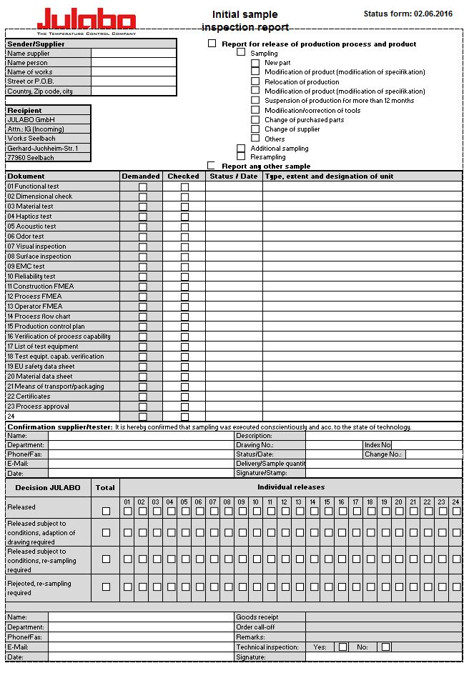

Image 1: cover sheet

The supplier fills in the basic information on the cover sheet. This includes:

Supplier:

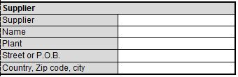

Image 2: supplier
Name supplier: [full company name
Name person: [contact / responsible person]
Works name: [manufacturing site and works]
Street or POB: [street or POB]
Country, ZIP; city: [address]

Reason for report
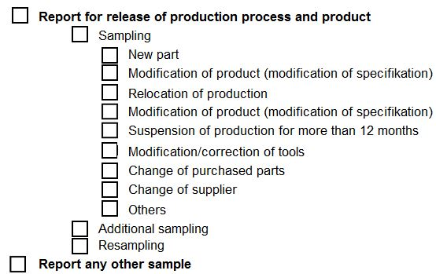

Image 3: reason for Initial Sample Test Report

Sampling information

Image 4: Information
Status of test, status/date, type, extent and designation of unit

Confirmation of sampling

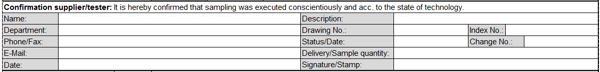

Image 5: confirmation of sampling

Individual- and total decision JULABO GmbH

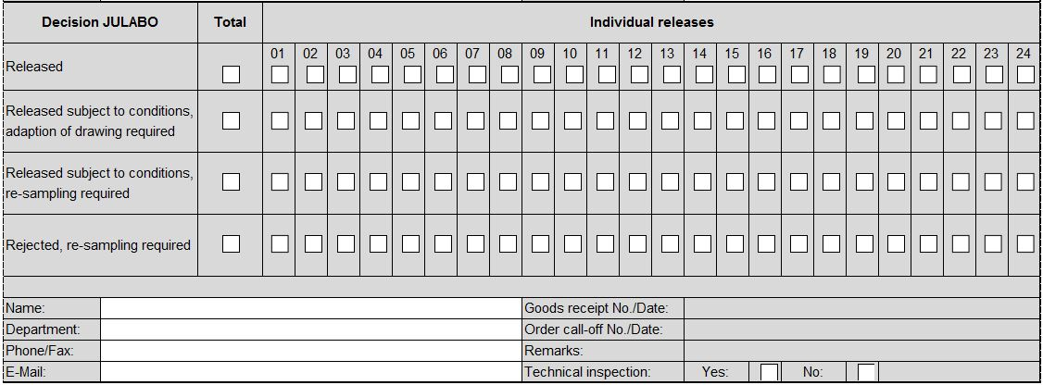

Image 6: Evaluation matrix

The individual and overall decision will be defined and reported by design department and the receiving department at JULABO GmbH.
For decision with technical inspection JULABO GmbH set inspection characteristics.

The total status can be:
- Released
- Released subject to conditions, adaption of drawing required and / or
- Released subject to conditions, re-sampling required
- Rejected, re-sampling required

Functional test

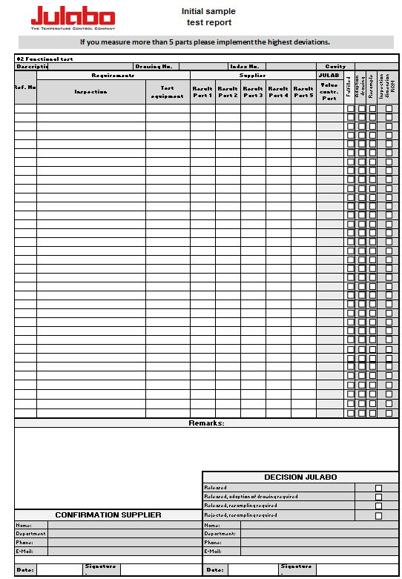

Image 7: Form for functional test

If a functional test is required, the supplier has to enter the defined functional properties on the form “functional test”. If there is no specification for test equipment the supplier defines the test equipment and enters the result in the column “Result”. In case of fulfillment, he ticks the box “fulfilled”. In case of nonfulfillment, the box is not ticked and the reasons as well as possible corrective measures are entered in the box “Remarks”. If there is not enough space, refer to attached supplementary sheets.

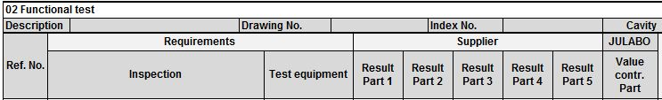

Image 8: Requirements

Name and address, … need to be supplemented

Cross-checks are applied at random by the purchaser, who will enter his results in the column “Actual value contr. part JULABO”. In case of nonfulfillment, the purchaser will choose one of the two possible decisions for each inspection. Adaption of drawing is chosen if all random samples of a characteristic are within the tolerance after the adaption and the function will not be impaired. Re-sampling is chosen if the function characteristics – even after the adaption of the drawing – do not fulfill the requirements and/or an adaption is not possible. If the correction of a component is necessary, re-sampling is required.

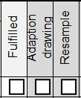

Image 9: Specific decision

Function characteristics which have been defined as test criteria for the incoming goods inspection must be ticked in the box “Inspection dimension RQM”. The Incoming Goods Control will store the information in the RQM system and will use it as reference as soon as the serial production has started.

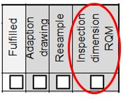

Image 10: RQM entry

Subsequently the decision is defined by the purchaser and confirmed with his name and signature.

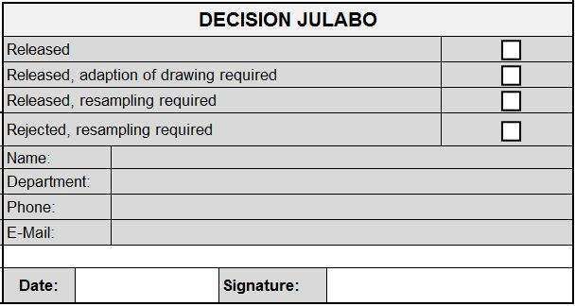

Image 11: decision matrix

Dimensional test
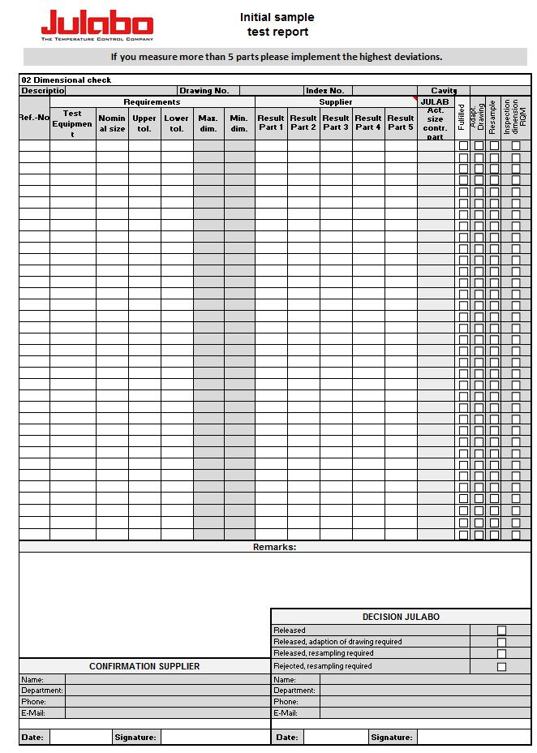

Image 12: form for dimensional test
All features (dimensions, properties and references to specifications) on the drawing must be numbered to ensure that clear referencing is possible between the drawing and the measurement result sheet during the sampling process. Dimensions which are shown on the drawing with GPS (Geometrical Product Specification) in a rectangular frame are like nominal sizes. They also must be numbered. The tolerance is located by form and position tolerance symbol.

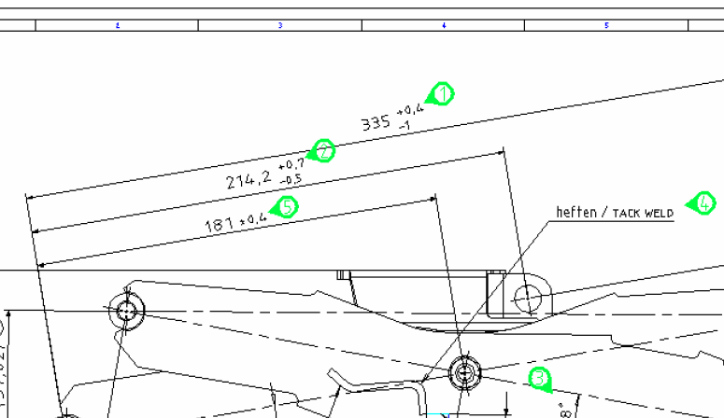

Image 13: numbering of measurements

On the sheet for the measuring results the specific ACTUAL measurements of first samples have to be listed for each nominal dimension and tolerance of the measuring point diagram. Measurements in brackets do not have to be checked. In case of fulfillment, the box “fulfilled” must be ticked. In case of nonfulfillment, the box is not ticked and the reasons as well as possible corrective measures are entered in the box “Remarks”. If there is not enough space, refer to attached supplementary sheets.

Image 14: Results
Cross-checks are applied at random by the purchaser, who will enter his results in the column “Actual size contr. Part JULABO”. In case of nonfulfillment, the purchaser will choose one of the two possible decisions for each characteristic. Adaption of drawing is chosen if all random samples of a characteristic are within the tolerance after the adaption and the function will not be impaired. Re-sampling is chosen if the measurements – even after the adaption of the drawing – do not fulfill the requirements and/or an adaption is not possible. If the correction of a component is necessary, re-sampling is required

Image 15: Detail decision

Dimensions or properties, which are defined as inspection criteria for the incoming inspection, must be crossed in the box headed "Inspection dimension RQM". These are defined together by the designer and the WEK personnel on the basis of the component function and empirical values. These are then placed in the RQM system by WEK and used for future series deliveries.

Image 16: RQM entry

Subsequently the decision is defined by the purchaser and confirmed with his name and signature.

Image 17: Decision matrix

Notes on testing and measurement accuracy of the equipment used

The necessary accuracy depends on the application and/or specification of the parts. It must be possible to measure all measuring and test characteristics with a justifiable accuracy taking all influences (equipment-specific/not equipment-specific) into consideration.

Criterion for selecting measuring equipment: Maximum permissible margin of error of measuring equipment must not be more than 10% of the tolerance.
Example: Tolerance range 0,3mm Maximum permissible margin of error 0,03mm.

The control of the measuring equipment in development and production is a prerequisite for the necessary trust in the accuracy and precision of measuring results and the resulting decision. The proof of accuracy as well as the regular control of the measuring and testing equipment has to be rendered by the supplier at the demand of the purchaser.

The valuation

The release of the samples by the purchases does not release the supplier from his responsibility for the quality of his products. Nor is it a delivery order. Submitted sampling documents which are not complete are maximum considered “Released subject to conditions”.

Decision | Details
Release | The sample parts and also the documentation have fulfilled all customer’s specifications and requirements. Therefore the supplier is authorized to deliver serial parts according to the release of the purchaser.
Release subject to conditions, adaption of drawing required | The sample parts and the documentation are accepted. The supplier is authorized for delivering serial parts. There is no re-sampling needed.  The drawing will be adapted subsequently by JULABO GmbH and the supplier will get a new version.  Until then the drawing will be adapted handwritten with name/ date and the changes. Supplier will get this interim drawing as contractual basis.  A new drawing will be made by design department JULABO within 10 days.  After receiving an updated drawing the interim drawing is no longer valid.
Released subject to conditions, re-sampling required | The lot is accepted under the condition of further processing without any problems.  Improved parts and corrected documentation must be sent and released before further production parts can be delivered.  Further deliveries are not allowed. Only if the supplier get a permission from JULABO GmbH for a certain period of time or a certain order quantity.
Rejection | Rejected means that the sample, the corresponding production batch, or the appropriate documentation has not fulfilled the customer’s requirements. An improved product and a revised documentation must be submitted and require release prior to delivery of further production quantities.

