Initial Sample Inspection Report - ISIR (external)
Process Owner (Role): | WEK-L
This version reviewed by: | L:Rotmann
Last edited by: | L:Rotmann
Changes from last version  (marked red within document text): |  | Transfer to a new template
Formal release of this type of document by QM, protocolled via SharePoint.

Table of Contents
1 Scope of Application 1
2 Purpose of this Process 1
3 Applicable Documents 2
4 Description 2
4.1 Labeling of initial samples 3
4.2 Filing of initial sample test report 3
4.3 Storage of initial samples 3
4.4 Explanatory notes on the template 1067 (EMPB/ISIR) 4
4.4.1 Cover Sheet 4
4.4.2 Functional Test: 7
4.4.3 Dimensional Test 9
4.5 Notes on testing and measurement accuracy of the equipment used 11
4.6 Evaluation 11
4.7 Terms and definitions 12
5 Abbreviations 12
6 Amendments 12
7 Instructions / Trainings 12

1 Scope of Application
Relevant for these departments/groups/roles/business units:
- JULABO GmbH
- Suppliers of JULABO GmbH
Relevant for these sites/locations:
☒ Seelbach and Lahr ☐ Seelbach only ☐ Lahr only
☐ Other: Click here to enter text.

2 Purpose of this Process
The purpose of the initial sampling procedure is to determine whether the supplier has correctly understood all design and specification documents and whether the manufacturing facility is capable of manufacturing producing products that meet these requirements during the actual production run (mass production) at the specified production volume.

3 Applicable Documents
Doc-ID | Doc-type | Doc-title
1069 | VA | Beschaffungsprozess
2152 | VA | PLM Gatewaylogik
1924 | VA | Erstbemusterung / Bemusterung / EMPB (Extern)
1849 | VA | Schlüsselkomponenten
1068 | VL | Initial sample inspection report
1097 | AA | Erstmusterprüfbericht in Axapta

4 Description
- Suppliers carry out all necessary tasks for the sampling based on the established criteria, characteristics, and documentation.
- Suppliers check the completeness and the fulfillment of the specifications, creates and signs the release forms.
- Suppliers forward the initial samples incl. the required documentation to the purchaser on schedule. If deviations regarding completeness and fulfillment of tasks occur during the release procedure, the cause has to be determined and corresponding, corrective measures are to be initiated. The purchaser has to be informed.
- The purchase evaluates the transmitted or presented documents and samples. The single and total release status is added to the cover page of the report. The release status is communicated to the supplier on the cover page.

Quantity of random samples:
Product | Random sample quantity | Comments
Sheet metal structural component | 3 pieces
Injection molding parts | 5 pieces | For specific characteristics the process capability must be verified for at least 25 parts, if required from purchaser.
All others | 5 pieces

When are initial samples required?
Initial samples are requested as a separate position in the order:
- New parts and new components
- Product changes (e.g. changes of construction, specifications, raw material)
- Change of suppliers

Caution: For structural components evidence must also be produced for all sub-assemblies and individual parts when not assembled, if the single parts are also produced by supplier. This applies even if only the structural component has been ordered.
The supplier is always obliged to obtain the approval from the relevant dispatcher promptly from:
- Re-sampling
- Re-location of production
- Change of production process
- Change of suppliers of products or services
- Change of purchased parts
- After reconstruction and maintenance of molds

4.1 Labeling of initial samples
The initial sample is to be labeled with:
- Part number
- Description
- Drawing number
- Index

It is important that it is possible to clearly assign the initial sample to the entire initial sample documentation including the measurement reports to guarantee a 100% retraceability and consistency of results and processes.
It is recommended to numerate the measured parts and thereby establish a connection to the results in the initial sample inspection report.

4.2 Filing of initial sample test report
The initial sample test reports of JULABO GmbH are filed in ERP-System and are kept for the term of the product plus on year. The person in charge in the WEK is responsible for the correct filing and integration in the ERP system.
The document will be archived for at least the duration of the product’s lifecycle, plus an additional year. The WEK administrator is responsible for ensuring the document is properly filed and integrated into the ERP system.
The document naming is done according to the following scheme:
Article number Index EMPB creditor.pdf - example: 7.406.0040 a EMPB 7180039.pdf
(Creditor No. of the respective supplier)

4.3 Storage of initial samples
As a general rule, JULABO does not archive initial samples.
If they have been released without conditions, they can be used for production.

Explanatory notes on the template 1067 (EMPB/ISIR)

4.4.1 Cover Sheet
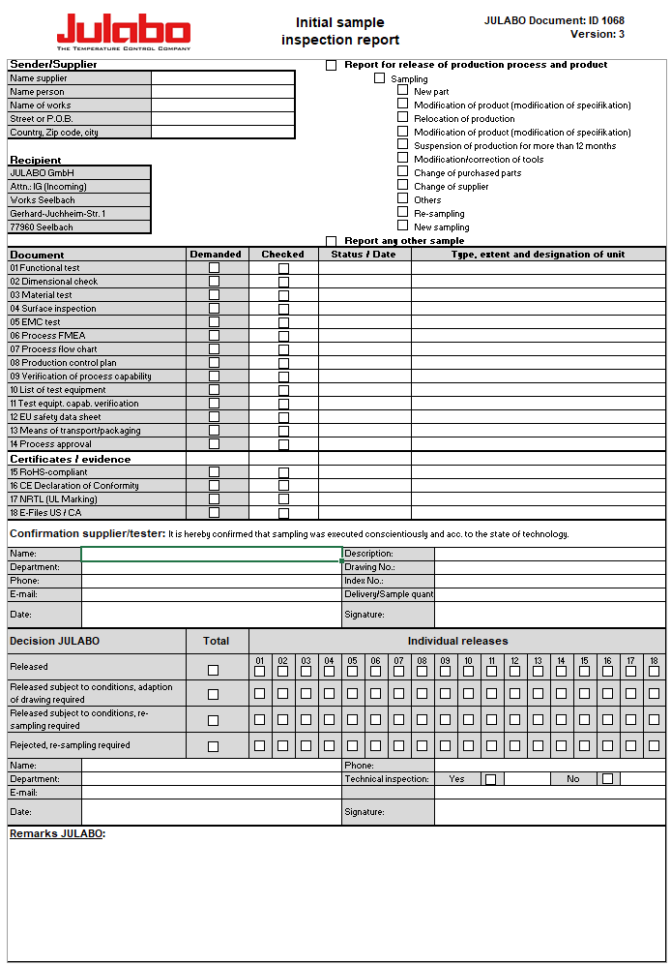
Figure 1: Cover sheet
Supplier:
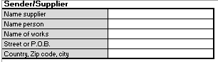
Figure 2: Supplier
Name supplier: [full company name]
Name person: [contact / responsible person]
Works name: [manufacturing site and works]
Street or POB: [street or POB]
Country, ZIP; city: [address]

Reason for report:
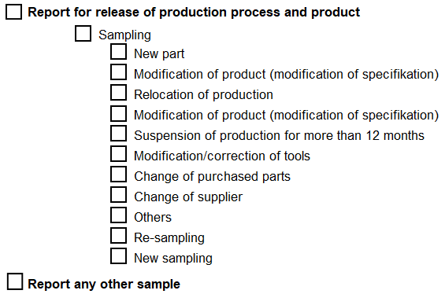
Figure 3: Reason for initial sample test report

Sampling information:
Figure 4: Sampling information
Status of test, status/date, type, extent and designation of unit

Confirmation of Sampling:
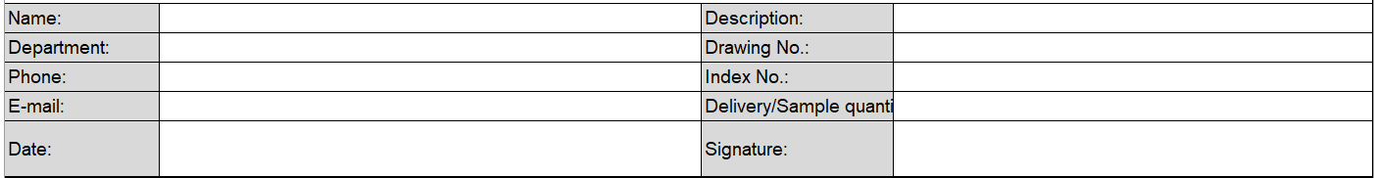

Figure 5: Confirmation of sampling

Individual- and total decision JULABO GmbH:
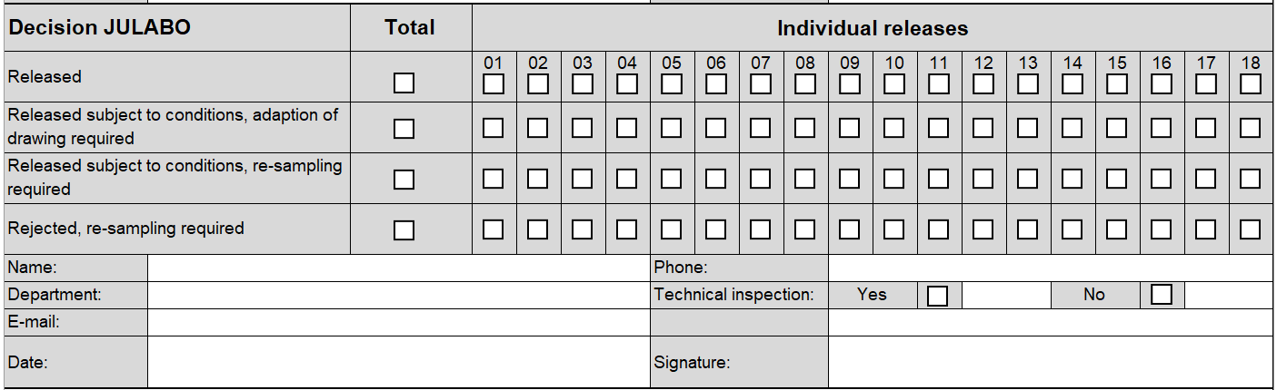
Figure 6: Evaluation matrix

The individual and overall decision will be defined and reported by design department and the receiving department at JULABO GmbH.
For decision with technical inspection JULABO GmbH set inspection characteristics.

The total status can be:
- Released
- Released subject to conditions, adaption of drawing required and / or
- Released subject to conditions, re-sampling required
- Rejected, re-sampling required

4.4.2 Functional Test:
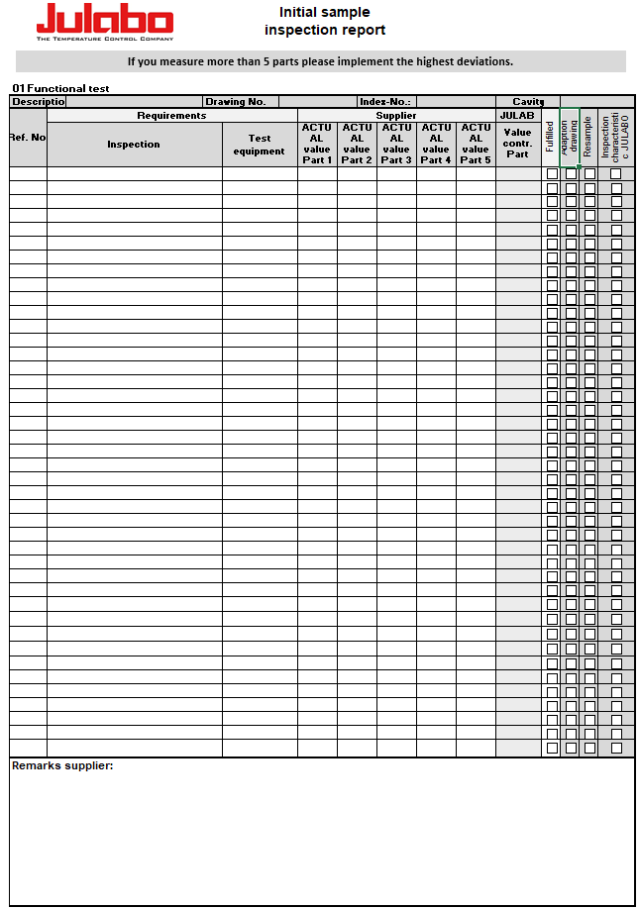
Figure 7: Functional test form
If a functional test is required, the supplier has to enter the defined functional properties on the form “functional test”.
If there is no specification for test equipment the supplier defines the test equipment and enters the result in the column “Result”. In case of fulfillment, he ticks the box “fulfilled”. In case of nonfulfillment, the box is not ticked and the reasons as well as possible corrective measures are entered in the box “Remarks”. If there is not enough space, refer to attached supplementary sheets.

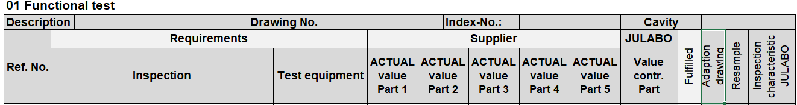
Figure 8: Requirements

Cross-checks are applied at random by the purchaser, who will enter his results in the column “Actual value contr. part JULABO”. In case of nonfulfillment, the purchaser will choose a decisions for each inspection.
- Adaption of drawing is chosen if all random samples of a characteristic are within the tolerance after the adaption and the function will not be impaired.
- Re-sampling is chosen if the function characteristics even after the adaption of the drawing do not fulfill the requirements and/or an adaption is not possible. If the correction of a component is necessary, re-sampling is required.

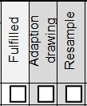
Figure 9: Specific decision

Function characteristics which have been defined as test criteria for the incoming goods inspection must be ticked in the box “Inspection characteristic JULABO”. The Incoming Goods Control will store the information in the inspection plan and will use it as reference as soon as the serial production has started.

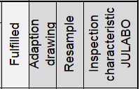
Figure 10: Inspection plan Entry

4.4.3 Dimensional Test
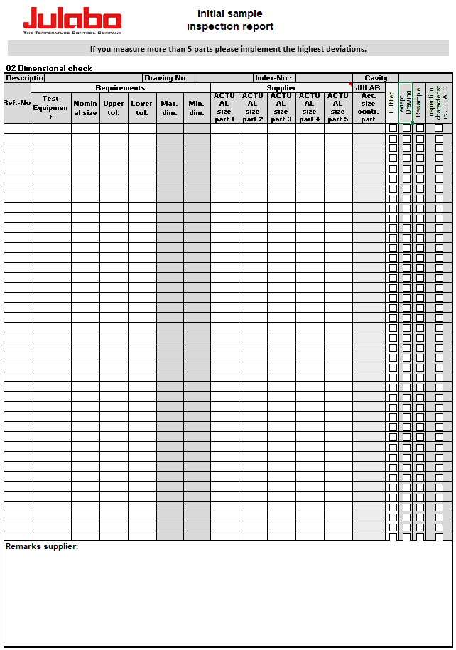

Figure 11: Dimensional test form
All features (dimensions, properties and references to specifications) on the drawing must be numbered to ensure that clear referencing is possible between the drawing and the measurement result sheet during the sampling process.

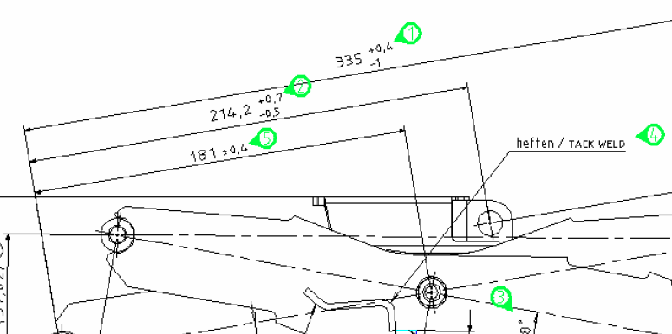
Figure 12: Measurement numerations
On the sheet for measuring results the specific ACTUAL measurements of first samples have to be listed for each nominal dimension and tolerance of the measuring point diagram. Measurements in brackets do not have to be checked. In case of fulfillment, the box “fulfilled” must be ticked. In case of nonfulfillment, the box is not ticked and the reasons as well as possible corrective measures are entered in the box “Remarks”. If there is not enough space, refer to attached supplementary sheets.
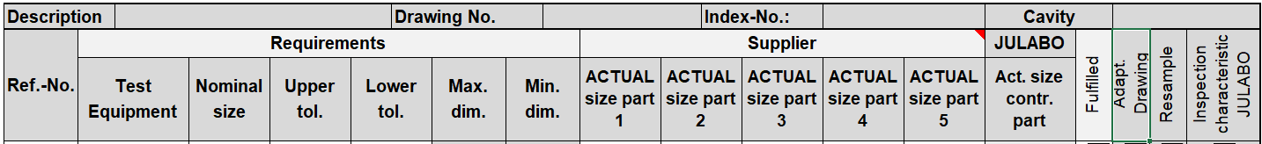

Figure 13: Results
Cross-checks are applied at random by the purchaser, who will enter his results in the column “Actual size contr. part JULABO”. In case of nonfulfillment, the purchaser will choose a decision for each inspection.
- Adaption of drawing is chosen if all random samples of a characteristic are within the tolerance after the adaption and the function will not be impaired.
- Re-sampling is chosen if the function characteristics even after the adaption of the drawing do not fulfill the requirements and/or an adaption is not possible. If the correction of a component is necessary, re-sampling is required.

Figure 14: Detail decision

Dimensions or properties, which are defined as inspection criteria for the incoming inspection, must be crossed in the box headed "Inspection characteristic JULABO". These are defined together by the designer and the WEK personnel on the basis of the component function and empirical values. The Incoming Goods Control will store the information in the inspection plan and will use it as reference as soon as the serial production has started.
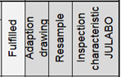
Figure 15: Inspection plan Entry

4.5 Notes on testing and measurement accuracy of the equipment used
The necessary accuracy depends on the application and/or specification of the parts. It must be possible to measure all measuring and test characteristics with a justifiable accuracy taking all influences into consideration.
Criterion for selecting measuring equipment: Maximum permissible margin of error of measuring equipment must not be more than 10% of the tolerance.
Example: Tolerance range 0,3mm Maximum permissible margin of error 0,03mm.
The control of the measuring equipment in development and production is a prerequisite for the necessary trust in the accuracy and precision of measuring results and the resulting decision. The proof of accuracy as well as the regular control of the measuring and testing equipment has to be rendered by the supplier at the demand of the purchaser.

4.6 Evaluation
The release of the samples by the purchases does not release the supplier from his responsibility for the quality of his products. Nor is it a delivery order. Submitted sampling documents which are not complete are maximum considered “Released subject to conditions”.

Decision | Details
Release | The sample parts and also the documentation have fulfilled all specifications and requirements. Therefore the supplier is authorized to deliver serial parts according to the release of the purchaser.
Release subject to conditions  - adaption of drawing required | The sample parts and the documentation are accepted. The supplier is authorized for delivering serial parts. There is no re-sampling needed.  The drawing will be adapted subsequently by JULABO GmbH and the supplier will get a new version.
Released subject to conditions  - re-sampling required | The lot is accepted under the condition of further processing without any problems.  Improved parts and corrected documentation must be sent and released before further production parts can be delivered.
Rejection | Rejected means that the sample, the corresponding production batch, or the appropriate documentation has not fulfilled the customer’s requirements. An improved product and a revised documentation must be submitted and require release prior to delivery of further production quantities.

4.7 Terms and definitions
First sample
First samples are products which were manufactured with standard equipment under standard conditions. Sampling with initial samples is called initial sample test and it serves as evidence for serial capability. Sampling for the release of production processes and products must be performed with initial samples. A positive or negative assessment of the initial sample (incl. documentation) by the purchaser results in the release of the product and the serial production or rejection of it.
Pre-serial sample
Pre-serial samples are manufactured with tools for small series or near-series systems which guarantee manufacturing process reliability. The applied manufacturing method corresponds with the subsequent serial production. To safe-guard the series start-up phase the products can be installed in pre-series products both with regard to their quality and produced numbers and are therefore suited for sampling.
Other samples
Other samples (DIN 55350, part 15) are products and material which are manufactured under not entirely serial conditions. Other samples may not be used for initial sample release. The release of other samples means that the product complies with the specifications, but it is not equivalent to serial release and does not give reason to waive the initial sample release procedure.

5 Abbreviations
See Infonet.

6 Amendments
Yearly at minimum, this work instruction is to be reviewed by the process owner‘s responsibility and, if required, necessary amendments to this document need to be conducted. The request for this is made via a system-side action.

7 Instructions / Trainings
By the process owner’s responsibility, all departments/groups/roles/business units mentioned in the scope of this document’s application are to be instructed or informed on new or changed processes. For additional instructions, see 1545-VA.docx.

